AFRICAN MUSICAL INSTRUMENTS

Nigeria

1. Eten people. SW of Jos town in Plateau State

Barankading, the most important drum
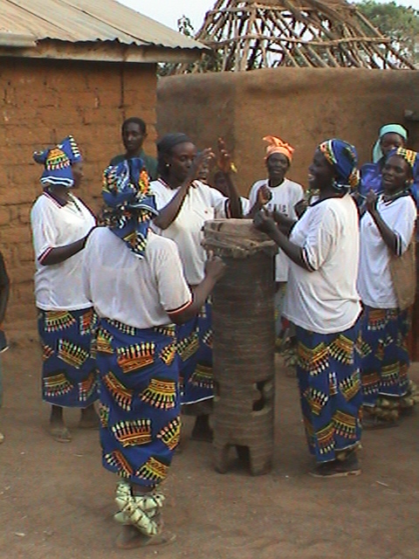

Ankle rattles made from fan-palm leaves
