KMAN LANGUAGE RESOURCES

Kman is also known as Miju (Midzu) in the literature.

Title | Date | Author
Miju dictionary | 1978 | Boro
Proposal for a writing system for Kman [=Miju], a language of Arunachal Pradesh. Working Paper | 2015 | Roger Blench

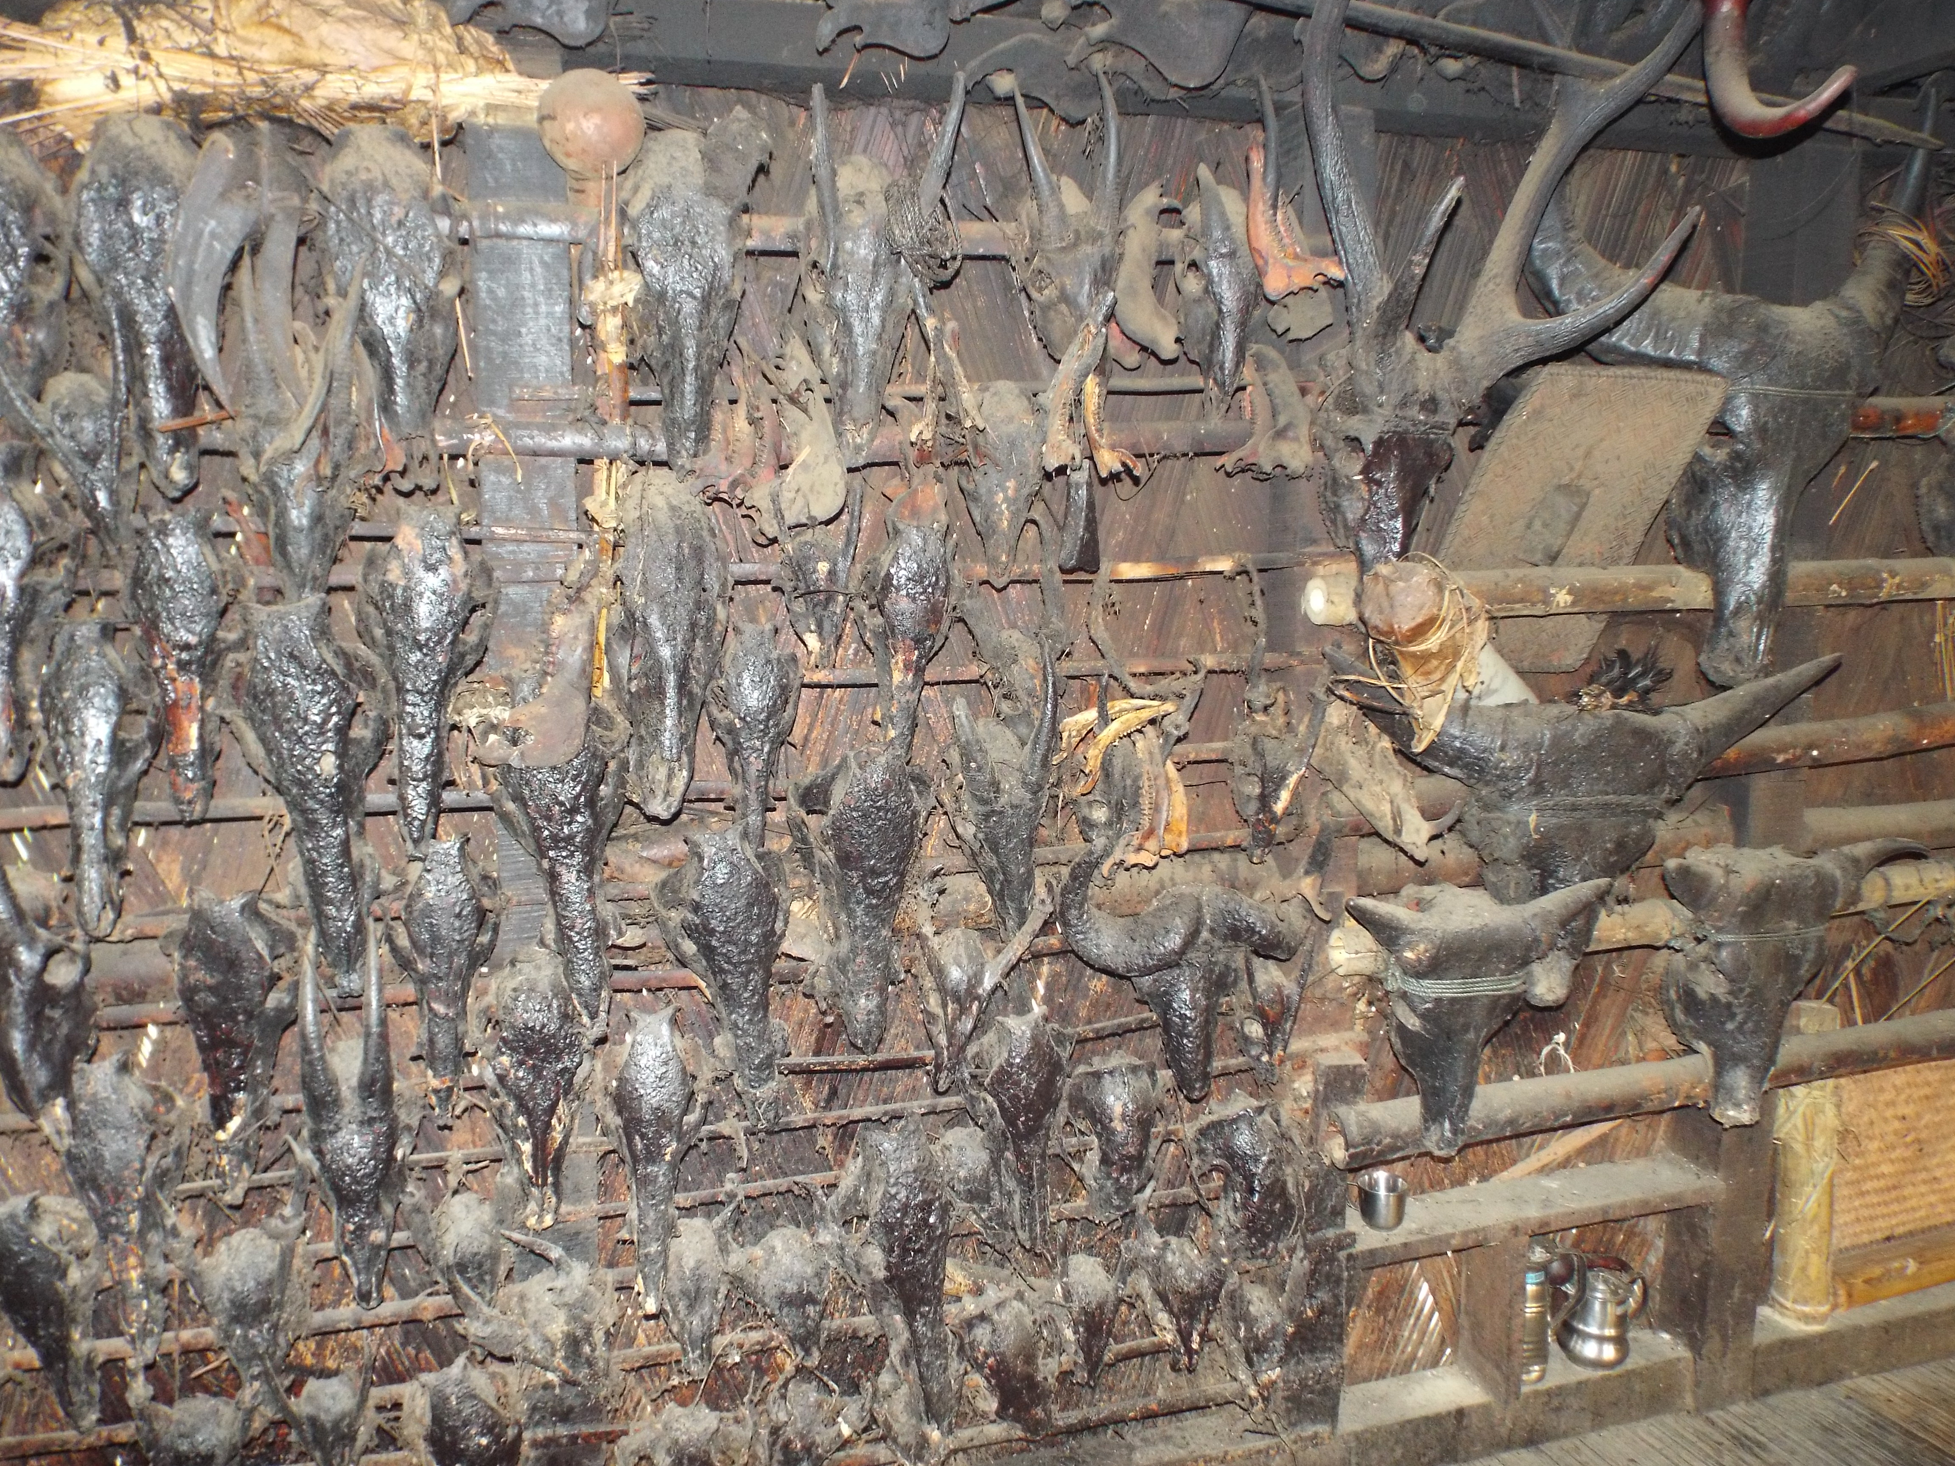

Bibliography

Boro, A. 1978. Miju dictionary. Shillong: The Philology Section, Research Department, North-East Frontier Agency.
Campbell, G. 1874. Specimens of Languages of India: Including Those of the Aboriginal Tribes of Bengal, the Central Provinces, and the Eastern Frontier. Calcutta: Printed at the Bengal secretariat Press.
Das Gupta, K. 1977. A phrase book in Miju. Shillong: Director of Information and Public Relations, Arunachal Pradesh. [Kaman (Miju), Parsuran Kund]
Konow, Sten 1902. Note on the languages spoken between the Assam Valley and Tibet. The Journal of the Royal Asiatic Society of Great Britain and Ireland, 1902: 127-137.
Krisikro, Sutik 2006. Tawra: tako zo bra/ käman, pït sai brat. Tezu: Graphic Systems.
Li, Daqin 2003. A study of Geman. [In Chinese]. Beijing: The Nationalities Press.
Macgregor, C.R. 1887. Journal of the Expedition under Col. Woodthorpe, R.E., from Upper Assam to the Irrawadi and return over the Patkoi Range. Proc. Royal Geographical Society, 9: 19-42.
Mills, J.P. 1952. The Mishmis of the Lohit Valley, Assam. The Journal of the Royal Anthropological Institute of Great Britain and Ireland, 82(1):1-12.
Needham, Jack F. 1886. A few Dîgârô (Târoan), (Mîjû) M'jû, and Thibetian Words. Shillong.
Robinson, W. 1856. Notes on the languages spoken by the Mi-Shmis. Journal of the Asiatic Society of Bengal, 24: 307-324.
Sun Hongkai, Lu Shaozun, Zhang Jichuan and Ouyang Jueya, eds. 1980. Menba, Luoba, Dengren de yuyan (The languages of the Menba, Luoba and Deng peoples). Beijing: Social Sciences Press.
Sun, Hongkai 1991. Zang Mianyu yuyin he cihui. [In Chinese]. Beijing: Zhōngguó Shèhuì Kēxué Chūbǎnshè.
Sun, Hongkai 1999. On the Himalayan languages of the eastern Himalayan area in China. Linguistics of the Tibeto-Burman Area, 22: 61-72.
Tawsik, Somodang 2014. Kaman-Tawrah. Tinsukia: Chitra printers.

