GALO LANGUAGE AND ANTHROPOLOGY

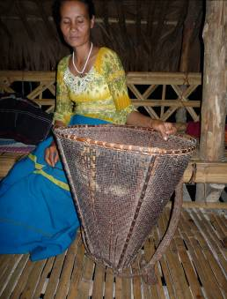

The Galo [Gallong] people

Topic | Image
Linguistics
Anthropology
Images

Bibliography

Das Gupta, S.K. 1963. An Introduction to the Gallong Language. Shillong, Northeast Frontier Agency.
Galo Language Development Committee. 2009. Galo-English Dictionary with English-Galo Index. Galo Welfare Society, Itanagar, Arunachal Pradesh, India
Post, Mark. 2007. A grammar of Galo. PhD dissertation, La Trobe University, Melbourne.
Riba, Bomchak 2009. Relevance of Indigenous Knowledge System of the Galo of Arunachal Pradesh for Sustainable Development of Forest Resources. Ph.D. Faculty of Environmental Science, Department of Geography, Rajiv Gandhi University, Itanagar, Arunachal Pradesh.

