PADAM LANGUAGE AND ANTHROPOLOGY

The Padam people

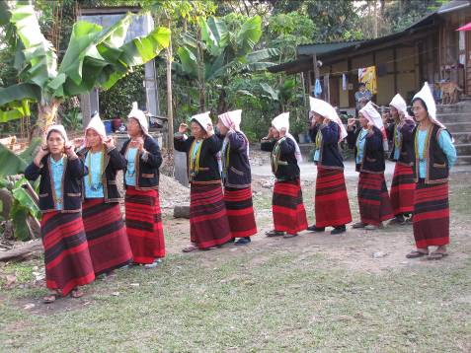

Topic | Image | Access
Linguistics |  | Page
Anthropology |  | Page

Bibliography

