MEMBA ANTHROPOLOGY RESOURCES

Title | Date | Author | Cover
The Membas of Arunachal Pradesh | 2006 | Dutta | 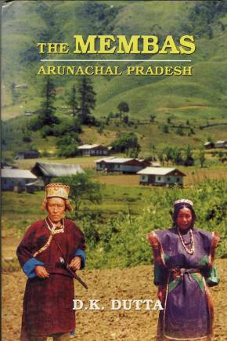

Bibliography

