CENTRAL MONPA LANGUAGE RESOURCES

Title | Date | Author | Image
An introduction to Central Monpa | 2007 | Das Gupta | 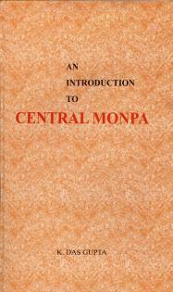

Bibliography

Das Gupta, R. [2nd ed.] 2007. An introduction to Central Monpa. Itanagar: Director of Research, Arunachal Pradesh Government.

