MEMBA LANGUAGE RESOURCES

Title | Date | Author | Image
Memba language guide | 2002 | Badu | 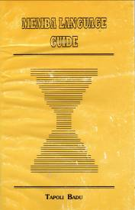

Bibliography

Badu, Tapoli 2002. Memba language guide. Itanagar: Director of Research, Arunachal Pradesh Government.
Sun Hongkai, Lu Shaozun, Zhang Jichuan and Ouyang Jueya, eds. 1980. Menba, Luoba, Dengren de yuyan (The languages of the Menba, Luoba and Deng peoples). Beijing: Social Sciences Press. [Darang, Xiachayu district; Geman, Xiachayu district; Menba, Cuona, Mama commune, Motuo]
Zhang Jichuan. 1986. Cangluo Menbayu jianzhi (A brief description of the Cangluo Menba language). Beijing: Nationalities Press. [Tsangla]

