MONPA OF TAWANG ANTHROPOLOGY RESOURCES

Title | Date | Author | Cover
The Monpas of Tawang | 2008 | Norbu | 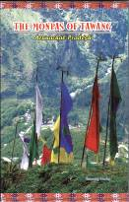

Bibliography

Norbu, Tsewang 2008. The Monpas of Tawang. Itanagar: Director of Research, Arunachal Pradesh Government.

