MONPA OF TAWANG LANGUAGE RESOURCES

Title | Date | Author | Image
An introduction to Tawang Monpa language | 2004 | Wangchu | 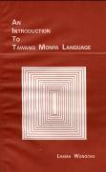

Bibliography

Wangchu, Lhama 2002. An introduction to Tawang Monpa language. Itanagar: Director of Research, Arunachal Pradesh Government.

