ARCHAEOLOGICAL RESOURCES FOR NORTHEAST INDIA

Title | Date | Author | Image
Ceramics of Northeast India | 2004 | Roy | 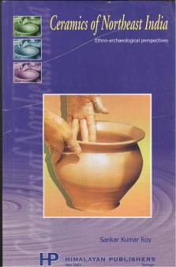

Ashraf, A.A. 1990. Prehistoric Arunachal. A report on archaeological exploration and excavation at Kamla Valley with reference to Parsi Parlo of Lower Subansiri District, Arunachal Pradesh. Itanagar: Directorate of Research.
Chakravarty, L. N. 1995 [1973]. Glimpses of the early History of Arunachal. Itanagar: Government of Arunachal Pradesh. 3rd edition.
Tripathy, Byomakesh. 1998. “Pre-historic archaeology of Arunachal Pradesh.”The Orissa Historical Research Journal XLII (1–4): 18–27.

